**Advanced Programming Practices**

Hackerrank Week-12

Name: Ronit Kumar Reg: RA2111032010009 Section: T2 Branch:CSE w/s OT

**Ques 1:**  Almost Sorted

**Problem:**

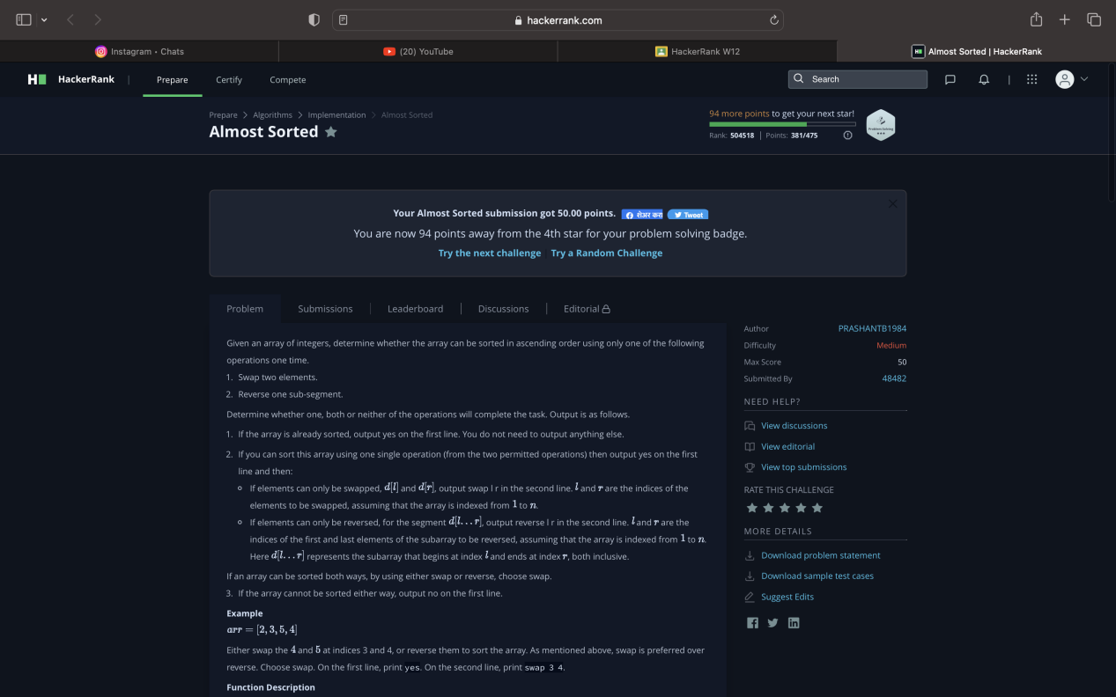

**Code:**

**def** getJumps(ar):

    jumps = []

**for** i **in** **range**(**len**(ar)-1):

**if** ar[i] > ar[i+1]:

            jumps.append(i)

**return** jumps

**def** isSortedWithSwap(ar, i, j):

    ar[i], ar[j] = ar[j], ar[i]

    jumps = getJumps(ar)

    ar[i], ar[j] = ar[j], ar[i] *# repair list*

**return** **len**(jumps) == 0

**def** isSortedWithReverse(ar, i, j):

    ar[i:j] = ar[j-1:i+1:-1]

    jumps = getJumps(ar)

    ar[i:j] = ar[j-1:i+1:-1] *# repair list*

**return** **len**(jumps) == 0

**def** magic(ar):

    jumps = getJumps(ar)

**if** **len**(jumps) == 0:

**print**('yes')

**elif** **len**(jumps) == 1:

        i = jumps[0]

        j = i+1

**while** j+1 < **len**(ar) **and** ar[i+1] == ar[j+1]: *#move point to last same element*

            j+=1

**if** isSortedWithSwap(ar, i, j):

**print**('yes')

**print**('swap', i+1, j+1)

**else**:

**print**('no')

**elif** **len**(jumps) == 2:

        i = jumps[0]

        j = jumps[1] + 1

**if** isSortedWithSwap(ar, i, j):

**print**('yes')

**print**('swap', i+1, j+1)

**else**:

**print**('no')

**else**:

        i = jumps[0]

        j = jumps[-1] + 2

**if** isSortedWithReverse(ar,i,j):

**print**('yes')

**print**('reverse', i+1, j)

**else**:

**print**('no')

n = **int**(**input**())

ar = **list**(**map**(**int**, **input**().split()))

magic(ar)

**Output:**

